Contents

Summary 2

ER Diagram 3

Relational Model 4

Database Architecture 7

Final Set of Tables 9

Specification of constraints 17

Specification of Indexes 19

Specification of Stored Procedures 20

Specification of Triggers 21

Specification of Views & Joins 22

Specification of Built in Functions 24

Specification of User Defined Functions 25

Security Plan 26

Appendix Database Creation 28

Appendix Table creation 30

Appendix Stored Procedures 35

Appendix Triggers 38

Appendix Views 40

Appendix User Defined Functions 42

Conclusion 43

Summary
Super Market Sales System

- There are many items in a Super Market and customer can chose any item can pay money and pick items out.

- Final validated purchases will be inserting in to the database.

- There are many items in the Super Market. Every item should have a brand and there are many brands for a particular item. One brand can have many items. But one item belongs to a category.

- There are suppliers who supply the brands of items. So one supplier can supply many brands as well as one brand can be supplied by many suppliers.

- Customer can purchased many items. Cashiers handle the transactions of purchased item. Cashier can handle many transactions.

ER Diagram

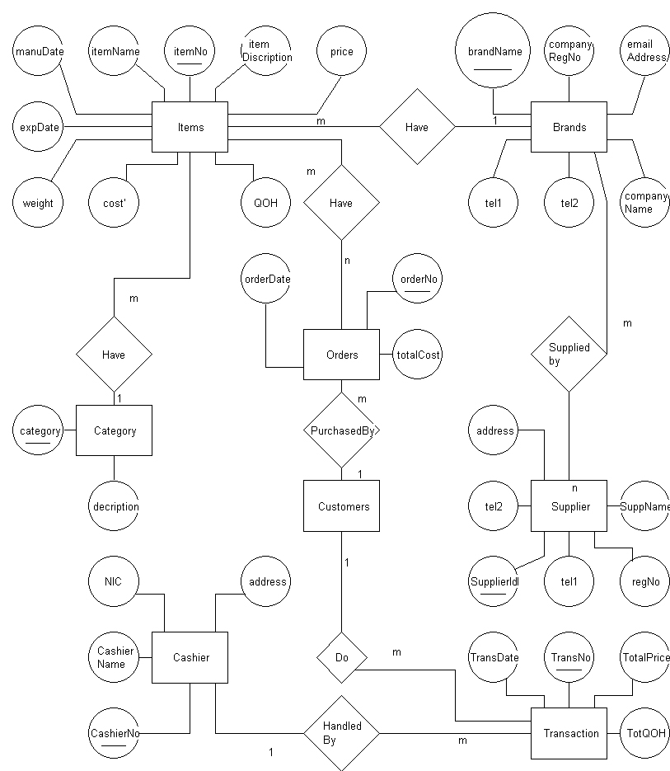

Relational Model
Relations

- tblCategory ( category, catDescription )

- tblItems ( itemCode, description, manufDate, expDate, weight, cost, image, Qoh, price, brandName, category )

- tblBrands ( brandName, companyRegNo, companyName, email, tel )

- tblTransactionData ( transactNo, trDate, itemCode, itemName, qoh, price, totalCost, cashierID )

- tblsuppliers ( supplierId, supplierName, emailAddress, regNo, telNo )

- tblCashiers ( cashierId, cashierName, cAddress )

- tblSupplierHeader ( supplierID, brandName )

- tblTransactHeader ( transactNo, itemcode )

Normalization

tblCategory ( category, catDescription)

tblItems ( itemNo, iDescription, manufDate, expDate, weight, cost, image, qoh, price, itemName

brandName, category )

tblBrands ( brandName, companyRegNo, companyName, email, tel )

tblTransactionData ( transactNo, trDate, itemCode, itemName qoh, price, totalCost, cashiereId )

tblSuppliers ( supplierId, supplierName, emailAddress, regNo, telNo )

tblCashiers ( cashierId, cashierName, c_Add_Line1, c_Add_Line2, c_Add_Line3)

Final set of Relations

- tblCategory (category, catDescription)

- tblItems ( itemNo, description, manufDate, expDate, weight, cost, image, qoh, price, brandName, category)

- tblBrands ( brandName, companyRegNo, companyName, email, tel)

- tblTransactionData (transactNo, traDate, itemCode, itemName, qoh, price, totalCost, cashierId)

- tblsuppliers ( supplierId, supplierName, emailAddress, regNo, telNo)

- tblCashiers ( cashierId, cashierName, c_Add_Line1, c_Add_Line2, c_Add_Line3)

- tblSupplierHeader ( supplierID, brandName)

- tblTransactHeader ( transactNo, itemcode)

Database Architecture
File Groups
In the dbSuperMarket database we have added the following file groups and files.
- primary file group
primary data file (dbSuperMarketpdf.mdf)

- secondary file groups
  - FGFixedData
    - Secondary data files
      - DbSuperMarketsdf1.ndf
      - DbSuperMarketsdf2.ndf
  - FGVariableData
    - Secondary data files
      - DbSuperMarketsdf3.ndf
      - DbSuperMarketsdf4.ndf
Strategies
We have some tables which are rarely updated in our database such as
- tblCtaegory
- tblSuppliers

So we can store those tables in the FGFixeDdata fileGroup.
And other tables are stored in another file group called FGVariableData.
At the same time we haven’t included any used data to primary file group in order to enhance the performance of the database. So we have changed the default file group to FGvariabledata file group.
Also by placing the different data files at different physical disks we can assure the data availability and performance ( But in this assignment we have not implemented that strategy due to the lack of resources )
The log file and the Back up files should be saved in a different disk from where the data is stored. Otherwise in a disk failure situation both the data and the back ups will be lost.

Reference: appendix database creation

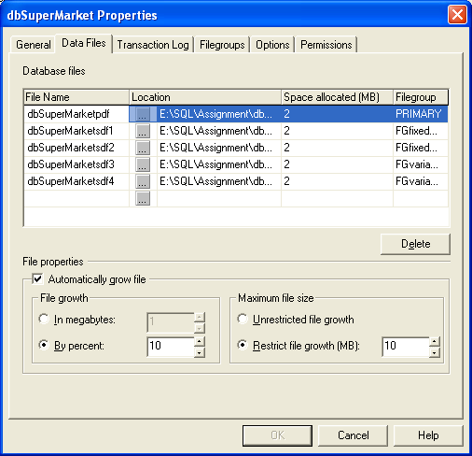

Screen print that displays the database property

Final set of Tables
Table ID : T1
Table Name : tblItems
Table Organisation : Indexed
Primary Key : itemNo

Field Name | Data type | Size | Description
itemNo | dataTypeItemNo | 8 | - Primary key-clustered  - User Defined data type  - Check constraint  ‘i [0-9][0-9][0-9][0-9][0-9]’
itemName | varChar | 20
iDescription | varChar | 50 | - Nullable
Price | Money | 8 | - Not null
Cost | Money | 8 | - Not Null
qty | Integer | 5 | - Not null
Weight | Float | 8 | - Not null
brandName | dataTypeBrandName | 20 | - Not null  - FK references tblBrand  - Nonclustered  - User defined Data Type
Category | dataTypeCategory | 20 | - Not null  - FK references tblCategory  - Non clustered index  - User Defined Data Type
Image | Image |  | - Nullable
expDate | Datetime |  | - Nullable
manufDate | Datetime |  | - Nullable

Reference Appendix Table creation

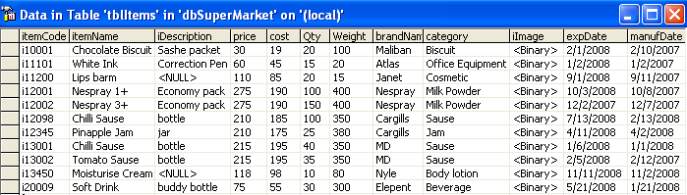
Screen Print that displays the table

Table ID : T2
Table Name : tblCategory
Table Organization : indexed
Primary Key : category

Field Name | Data Type | Size | Description
Category | dataTypecategory | 20 | - Primary Key – clustered  - User Defined Data Type
catDescription | Varchar | 50 | Allow Nulls

References Appendix Table Creation

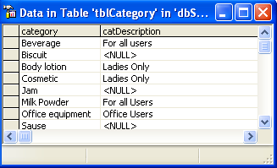

Screen Print that displays the table

Table ID : T3
Table Name : tblbrands
Table Organization : Indexed
Primary Key : brandName
Alternate Key : companyRegNo

Field Name | Data type | Size | Description
brandName | dataTypeBrandName | 20 | - PK_clustered  - User defined Data Type
Company Name | varChar | 30 | - Not Null
CompanyRegNo | Char | 10 | - Not Null  - Unique key
Tel | Char | 11 | - Not Null
email | Char | 30 | - Nullable

Reference : Appendix Table Creation

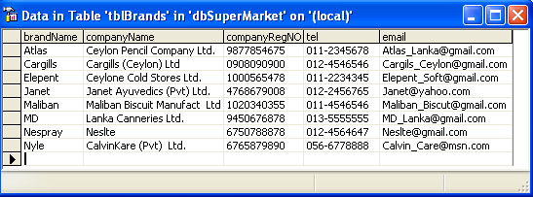

Screen Print that displays the table

Table ID : T4
Table Name : tblTransactionData
Table Organization : Indexed
Primary Key : orderNo

Field Name | Data type | Size | Description
transactNo | dataTypeTrsactNo | 8 | - PK_clustered  - Check constraints  ‘[0-9][0-9][0-9][0-9][0-9]’
trDate | Datetime |  | - Non-clustered index  - Not null  - Default-System Date
itemCode | dataTypeItemcode |  | - Not null  - FK references tblItems
itemName | datatypeitemName | 20 | - Not null  - FK references tblItems
qoh | Integer | 4 | - Check constraint  (Qoh<=5000 and Qoh>0)  - Not null
Price | Money |  | - Not null
Totalcost | Money |  | - Not null
cashierId | dataTypeCashierId | 4 | - PK_Clustered  - FK references tblCashiers

Reference : Appendix Table Creation
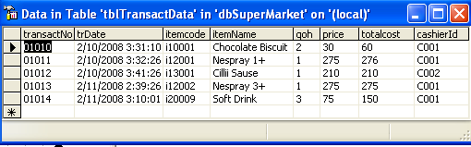
Screen Print that displays the table

Table ID : T5
Table Name : tblSuppliers
Table Organization : Indexed
Primary Key : supplierId

Field Name | Data type | Size | Description
supplierId | dataTypeSupplierId | 8 | - PK_Clustered  - Check Constraint  ‘[S][0-9][0-9][0-9][0-9][0-9]’
supplierName | Char | 20 | - Not null  - Unique Key – Non clustered
emailAddress | Char | 30 | - Nullable
regNo | Char | 10 | - Not null  - Unique Key – non clustered
telNo | Char | 11 | - Not null

Reference : Appendix Table Creation

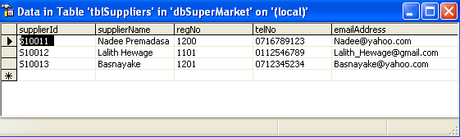

Screen Print that displays the table

Table ID : T6
Table Name : tblCashiers
Table Organization : Indexed
Primary Key : cashierId

Field Name | Data type | Size | Description
cashierId | dataTypeCashierId | 4 | - PK_Clustered  - Check Constraint  ‘[S][0-9][0-9][0-9]’
cashierName | Char | 20 | - Not null  - Unique Key – Non clustered
C_Add_Line1 | varChar | 10 | - Not null
C_Add_Line2 | varChar | 20 | - Not null
C_Add_Line2 | varChar | 20

Reference : Appendix Table Creation

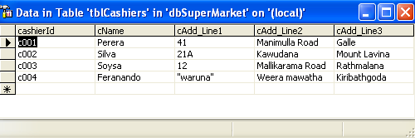

Screen Print that displays the table

Table ID : T7
Table Name : tblsupplierHeader
Table Organization : Indexed
Primary Key : supplierId, brandName

Field Name | Data type | Size | Description
supplierId | dataTypeSupplierId |  | - Primary key  - Fk references tblSuppliers
brandName | dataTypebrandName |  | - Primary key  - Fk references tblBrands

Reference : Appendix Table Creation

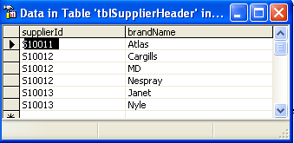

Screen Print that displays the table

Table ID : T8
Table Name : tbltransactHeader
Table Organization : Indexed
Primary Key : transactNo, itemCode

Field Name | Data type | Size | Description
transactNo | datatypeTransactNo |  | - Primary key  - Fk references tbltransactData
itemCode | datatypeItemCode |  | - Primary key  - Fk references tblItems

Reference : Appendix Table Creation
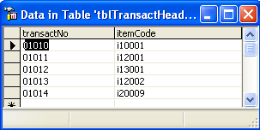

Screen Print that displays the table

Specification of Constraints

Used Constraints
Nullability
CHCK Constraint
UNIQUE Constraint
PRIMARY KEY Constraint
FOREIGN KEY Constraint

Here I have used the table tblItems to explain the using of constraints

Field Name | Data type | Size | Description
itemNo | dataTypeItemNo | 8 | - Primary key-clustered  - User Defined data type  - Check constraint  ‘i [0-9][0-9][0-9][0-9][0-9]’
itemName | varChar | 20
iDescription | varChar | 50 | - Nullable
Price | Money | 8 | - Not null
Cost | Money | 8 | - Not Null
qty | Integer | 5 | - Not null
Weight | Float | 8 | - Not null
brandName | dataTypeBrandName | 20 | - Not null  - FK references tblBrand  - Nonclustered  - User defined Data Type
Category | dataTypeCategory | 20 | - Not null  - FK references tblCategory  - Non clustered index  - User Defined Data Type
Image | Image |  | - Nullable
expDate | Datetime |  | - Nullable
manufDate | Datetime |  | - Nullable

- Nullability
Specifies whether a column can have NULL values or not.
Here we have allowed null values for several fields.
Eg : Image, expDate, manufDate, iDescription
User can leave these fields blank without specifying any values.

Here we also have Not Null Fields these fields cannot be left empty.
User can’t leave these field without specify.
Eg: Price, Cost, qty ,Weight, brandName, category

- CHCK Constraint
Check Constraint are used to enforce domain Integrity.
itemCode check constraints.
itemCode must begin with ‘i’ and must be in the format of ‘i[0-9][0-9][0-9][0-9][0-9]’
Eg: i00011

- UNIQUE Constraint
Unique key is a primary key. Here I haven’t use any unique key.
But if you refer tblSuppliers supplierName is use as a unique key.
Using a unique key we can identify an entity uniquely.

- PRIMARY KEY Constraint
Primary key is to uniquely identify a row in a table.
ItemCode is the Primary Key of tblitems.

- FOREIGN KEY Constraint
Foreign key is to identify a relationship between tables and thereby enforce domain and referential Integrity.
brandName and Category are the foreign keys that used in the tblItems.
brandName refers to the brandName column of the tblBrands.
category refers to the category column of the tblCategory.

References: Appendix Table Creation

Specification of Indexes

Indexes are of two types:
1) Clustered Index
2) Non clustered Index
To explain indexes and there behaviour I’ll be using the same table above.

1) Clustered Index
In the tblItems the clustered index is the Primary Key itself. the primary key is by default, a clustered index. there by we sort and the data rows in the table based on the Primary Key itemCode.

Reference: appendix table Creation

2) Non-Clustered Index
In the tblitems there are several non clustered indexes. Following is a list of columns non-clustered indexes specified in the tblItems.
brandName
category

By using indexes we can uplift the performance of the database

Reference: Appendix table Creation

Specification of Stored Procedures

A stored procedure is a group of TSQL statements compiled into a single execution plan.
A stored Procedure returns data in the following ways:
1) Input Parameters – Allows an Invoker to pass a data value to the procedure.
2) Output Parameter – allows the stored procedure to pass a data value back to the invoker.
3) Return Code – allows the Stored Procedure to return an integer value to the invoker, then the stored procedure returns a default value 0 or 1, depending on the success or failure in execution.

Following are some examples of stored Procedures:

sp_showSuppliers
This stored procedure displays the Supplier details given the item number. The output of this stored procedure will be displayed in the grid.
This stored procedure uses one input parameter (@itemNo) and displays the following columns.
brandName from the tblItems.
sName, email, tel from the tblSupplier
Here we use the return code which will pass 0 if the procedure executes successfully and 1 if it fails as mentioned above.

Sp_salesDetails
This stored procedure displays the sales details from given itemcode. Just like the earlier stored procedure this one also accepts one parameter and displays the appropriate sales details in the grid. Here it uses one input parameter @itemCode which will accept the itemCode and there by display the following columns.
itemName from the tblItems
price from the tblTransactData
qoh and totalvalue from the tblTransactHeader.

Sp_ItemsForCategory
This stored procedure is to display items for specific category. It uses @category as input parameter and display following data for the category.
itemCode, itemName, brandName from the tblItems

Specification of Triggers
A trigger is a type of Stored Procedure that is automatically executed in response to certain events on a particular table in a database. Triggers can restrict access to specific data.
Microsoft SQL server only supports two types of triggers which are either AFTER or INSTEAD OF even though there are many types of triggers in SQL.
A Trigger can be executed for the following types of events (actions):
- Update
- Insert
- Delete

AFTER Triggers:
- The trigger executes after the statement that triggered it completes.
- Can be specified only for tables not for views.
- Can specify multiple AFTER triggers for each triggering action.

trgUpdateSupTelNo
A trigger for the table tblSuppliers executed upon an update action on the table.

Sup_Delete
A trigger for the table tblSuppliers executed upon a delete action on the table.

Reference: Appendix Trigger

Instead of triggers:
- The trigger executes in place of the triggering action.
- Can be specified for both tables and views.
- Can define only one INSTEAD OF action for each triggering action.

trgUpdateExpDate
A trigger for the table tblitems which prevents updating actions.

Reference: Appendix Triggers

Specification of Joins & views
Joins
A join can be defined as an operation that includes retrieval of data from more than one table at a time.

Some types of Joins
- Inner Join – displays only the values that have a match in the both joined tables.
- Outer Join- the result set of these joins contains all the rows from one table and matching rows from another.
- Left Outer Join
- Right Outer Join
- Full Outer Join

- Cross Joins – A join that includes more than one table without any condition in the ON clause. The outputs of these joints are called Cartesian Products.

Reference: Appendix stored Procedures, appendix Views and Appendix User Defined Functions.

Views
A view is a virtual table, which consist of a subset of columns from one or more tables.
Though it is similar to a table, it is not stored in the database. It is a query stored as an object.

Vwitemdetails
This view is to display item details.
It contains the following columns
- itemDescrip (brandName+category)
- ItemPrice (price)
- Item (image)
- ManufDate
- expDate
It contains the data from following three tables. Inner joins are used to map data between these tables.
- tblItems
- tblBrands
- tblcategory

Reference: Appendix Views

vwSalesSummary
This view to display summary of sold items group by itemCode
It contains the following columns.
- itemCode
- total value of Sold items

This view contains data only from tbltransactData

Reference: Appendix Views

Specification of Built in Functions
There are various types of built in functions, following are some them.

Aggregate Functions
- COUNT – counts the number of rows in the table
- SUM – used to find the total of numeric columns
- AVG – to find the average of numeric columns
- MAX – to find the maximum value in a numeric column
- MIN – to find the maximum value in a numeric column

Datetime functions

- getDate()
- dateDiff()
- dateName()
- datePart()
- dateAdd()

String Functions

These functions can be used as part of any character expression. These functions are used for various operations on strings.

Eg:
LOWER ( character expression)
CHAR ( Integer_expression)
REVERSE ( character_expression)

Following are some of the examples of Built in Functions:

- To find the average sales for the day

Select Avg ( salesValue ) as “average Sales for the Day”

- To find the sales of the Day

Select sum(total cost) as “Total sale of the Day”

- To count no of items

Select count(itemCode) from tblItems

- To find maximum cost item and minimum cost item

Select Min(cost) as “Minimum cost item”
Max(cost) as “Maximum cost Item”

Specification of User Defined Functions

Types of user Defined Functions
- Scalar Functions
- Table valued Functions

Scalar Functions

A scalar user-Defined function returns one of the scalar data types Text, ntext, image and timestamp data types are not supported.

Eg: maxPriceitem
A function which accepts one parameter (a char) and returns a type decimal parameter. This function returns the price of the highest priced item when the parameter passes ‘all’, and if the parameter passes the brandName it will return the price of the highest priced item for a given brand.

Table Valued Functions

An Inline Table-value user-defined function returns a table data type and is an exceptional alternative to a view as the user-defined function can pass parameters into a T-SQL select command.

Eg: cashierDetail
This function returns a table called @cashierTab which displays data about a given cashier Name.

Reference: Appendix User Defined function

Security Plan

Database access for system administrator

Administrator is the person who has full permission to select, Insert and delete data from the database superMarketSales. To access the database system administrator need the password. In this database the password to the administrator is assigned as “sa54321”.

Query for System administrator:

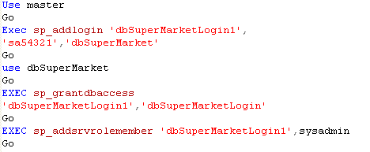

Database access for Purchase Manager

Developer is the person who updates the table tblItem. Developer grant permission to do the update, insert and select to all data fields instead of price and expdate. He also has a password which grants the persons accessibility on the table tblItem.

Query for the Developer

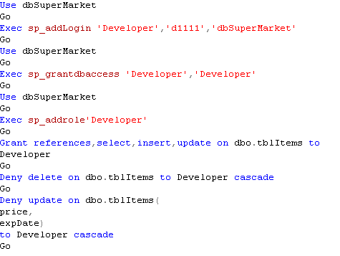

Appendix Database Creation

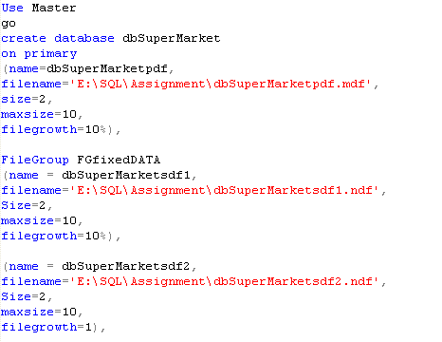
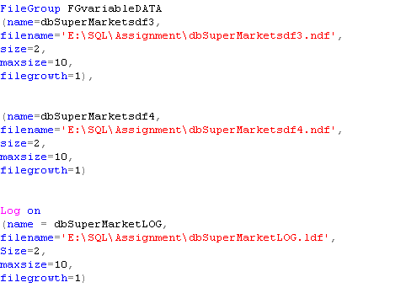

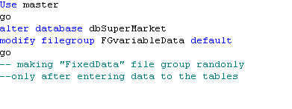
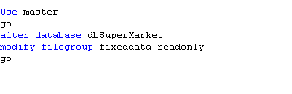

Appendix: Table Creation

Creating User defined data types

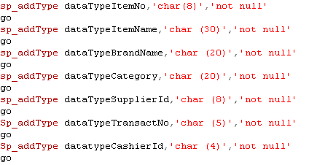

Creating tables
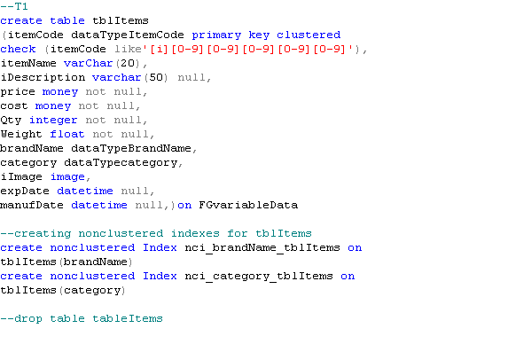

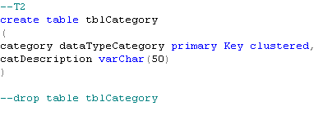

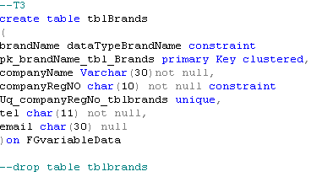

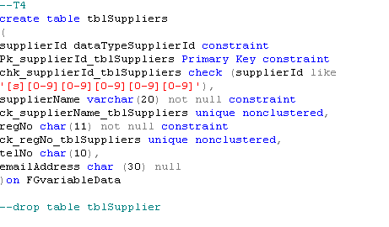

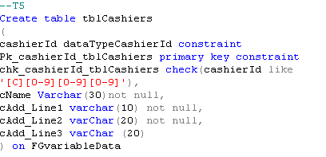

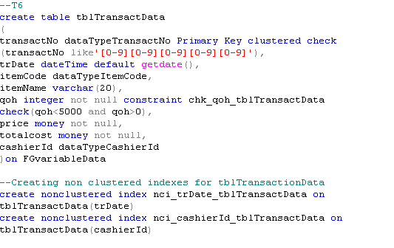

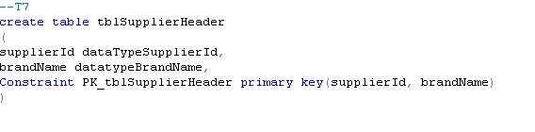
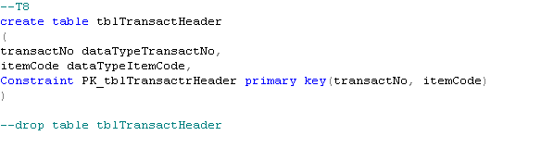

Implementing referential Integrity using foreign Key constraints
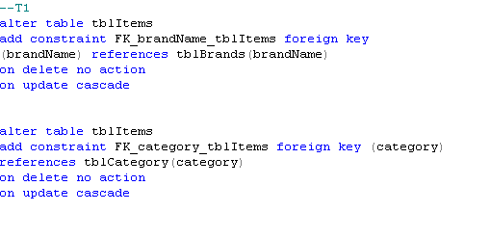
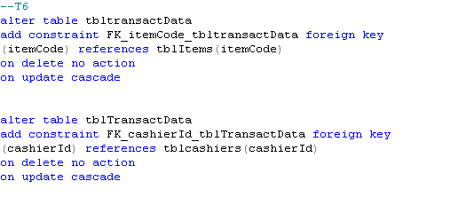
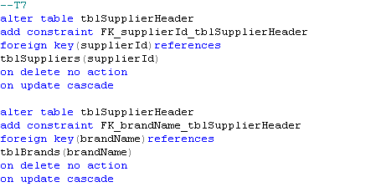
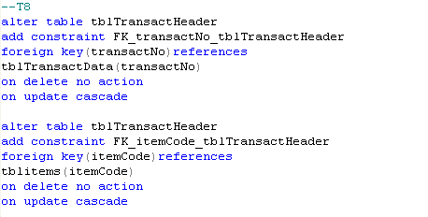

Appendix: Stored procedures

Sp_showSuppliers

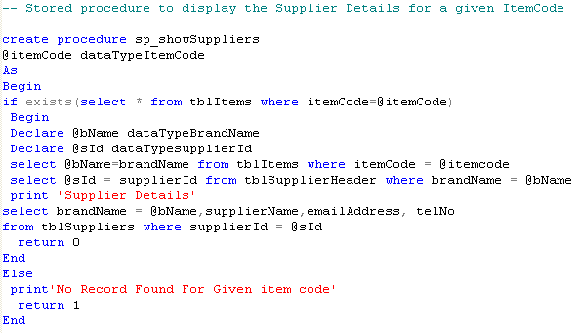

Output:

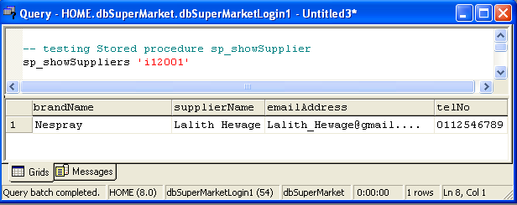

Sp_SalesDetails

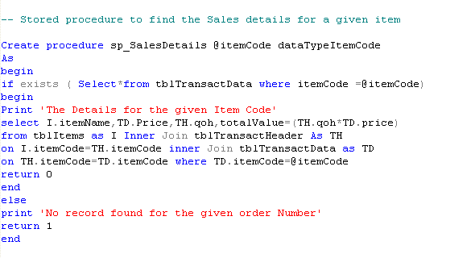

Output:

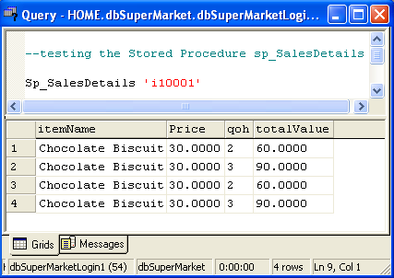

Sp_ItemsForCategory
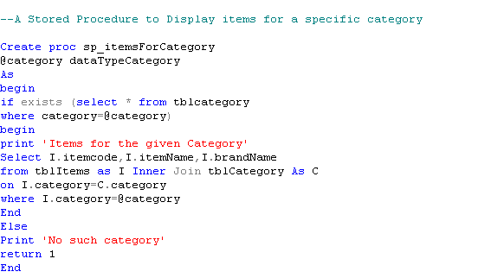

Output:
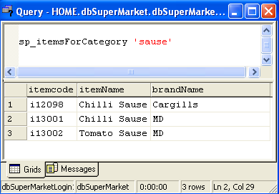

Appendix Triggers

After trigger - trgUpdateSupTelNo

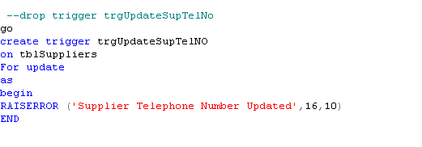
Output

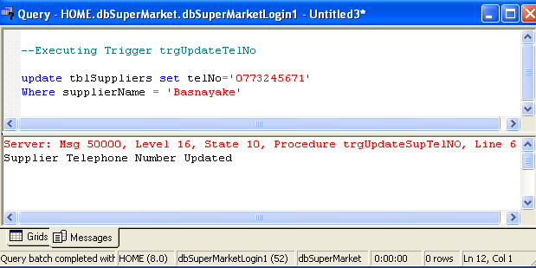

Sup_Delete

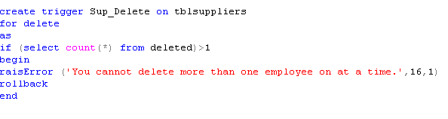

Instead of trigger – trgUpdateExpdate

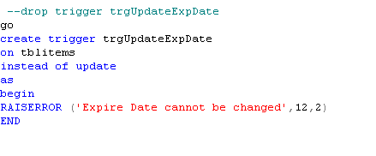

Appendix Views

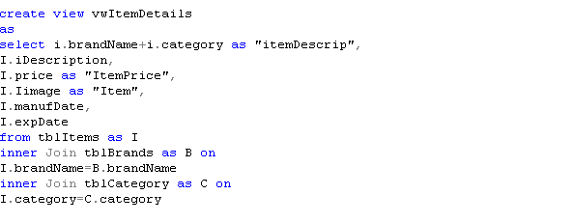
Output :

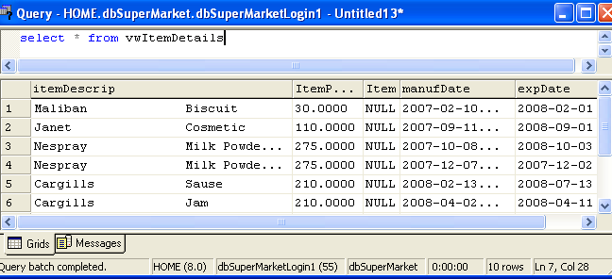

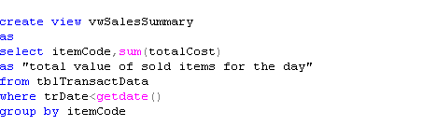
Output :

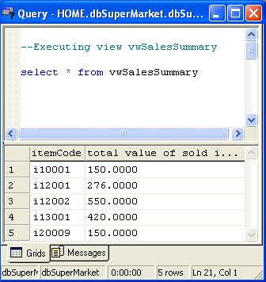

Appendix: User Defined Functions

An example for Scalar function
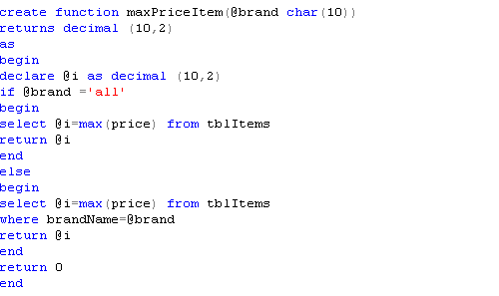

An example for Scalar valued function
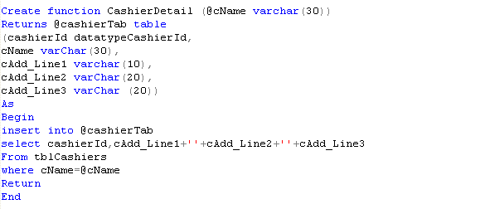

Conclusion

This assignment has given our group an open opportunity to not only learn, but also to understand the importance of working as a group as it’s a core factor today, in the IT industry. So I take this opportunity to thank our lecturer Mr. Murshid for giving us an opening and the taste of working in a real world environment.

CD contains

Back up file of original database. (dbSuperMarket)

Back ups of primary, secondary and log files.

Copy of documentation. (SQL assignment)

Query files that are used to implement the database.

